Business Statistics with R: Payday Loan study case

Gibran Makyanie

Table of Contents

Problem Description 1

Data Dictionary 3

Does receiving a payday loan change well-being? If so, how much? 4

Does taking payday loan makes people more or less likely to experience an adverse credit event? 5

In-depth Analysis 6

# Problem Description

A financial conduct regulator needs to investigate the effect of payday loans. A dataset of a survey from 5,000 customers where they reported their well-being and a measure of their socio-economic status linked to their credit file is available.

Two questions arose:

1. Does receiving a payday loan change well-being? If so, how much?

2. Does taking payday loan makes people more or less likely to experience an adverse credit event?

rm(list=ls())  
library(tidyverse)  
library(DataExplorer)  
library(emmeans)  
library(gridExtra) # for grid.arrange()  
library(gmodels)  
library(MASS)  
options(width=100)

# --------- import data  
payday <- read.csv('payday.csv')  
  
# --------- variable check  
payday$credit.score <- as.numeric(payday$credit.score)  
payday$SES <- as.numeric(payday$SES)  
payday$well.being <- as.numeric(payday$well.being)  
#payday$adverse.credit.event <- factor(payday$adverse.credit.event, levels = c(0,1), labels = c("no adverse", "adverse"))  
payday$id <- NULL  
  
view(payday)  
str(payday)

## 'data.frame': 5000 obs. of 5 variables:  
## $ credit.score : num 590 440 470 480 570 550 550 580 540 560 ...  
## $ SES : num 16 14 13 14 18 17 15 18 16 14 ...  
## $ loan : int 1 0 0 0 1 1 1 1 1 1 ...  
## $ well.being : num 5 4 3 2 7 7 4 7 5 6 ...  
## $ adverse.credit.event: int 0 1 0 1 0 0 1 0 0 1 ...

plot_missing(payday)

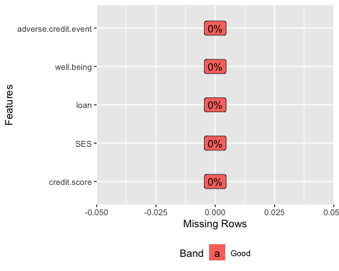

Data Dictionary

|  |  |
| --- | --- |
| Variable | Description |
| id | Customer ID |
| credit.score | Customer’s credit score [400 to 600] |
| SES | People’s socio-economic status, with higher scores indicating higer status [1 to 26] |
| loan | A dummy variable indicating whether or not people were given the payday loan [0: no or 1: yes] |
| well.being | Customer’s self-reported well-being on a 1-7 scale, with 7 being the highest well-being [1 to 7] |
| adverse.credit.event | A dummy indicating whether there was an adverse credit event in the next year [0: no or 1: yes] |

# Does receiving a payday loan change well-being? If so, how much?

Yes, loan significantly affects well-being by a decrease of .132 in well-being score if one receives payday loan, 95% CI[(-.242) – (-.022)], and no decrease otherwise, given SES and credit score held constant.

Individually, loan, SES, and credit score have significant effect and a positive correlation when used as a predictor of well-being. Put it simply, as one increases, well-being increases too. However, well-being is best explained by using the combination of loan, credit.score, and SES as predictors using a multiple regression model, $R^{2}$ = .694. Figure 1 describes how each predictor changes well-being when used together.

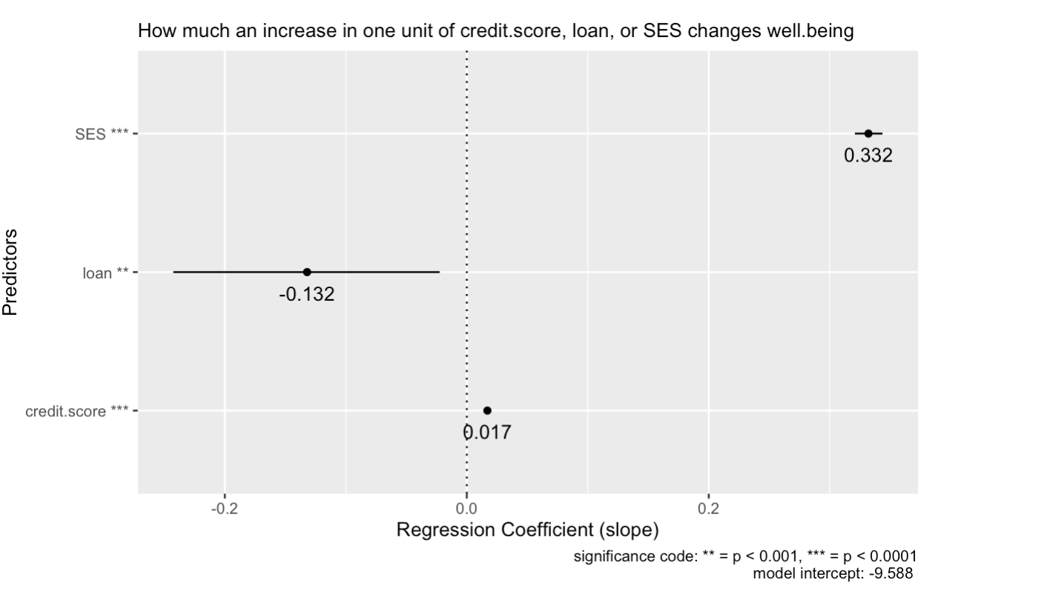

Figure 1. Regression coefficient of credit score, loan, and SES to describe the change in well-being per each unit increase.

Relative to other predictors, although still significant, loan has the least significant effect towards well-being, $F(1,4996)=7.456$, $p=.006$. This is expected since loan and credit.score are highly correlated, $R^{2}$ = .494, whilst credit score can explain well-being better than loan, $R^{2}$ = .494 and $R^{2}$ = .354 respectively. Thus, making the model shifts its attention more to credit score than loan when it comes to predicting well-being.

As for the magnitude of change, holding credit.score and SES constant, one unit increase on loan variable predicts a decrease of .132 unit of well-being 95% CI[(-.242) – (-.022)]. Such change is significant, $t(4996)=-2.359$, $p<.001$.

# Does taking payday loan makes people more or less likely to experience an adverse credit event?

Those taking payday loan are less likely to experience adverse credit event. And Social Economic Status does not have a significant effect on adverse credit event nor on the relationship loan has with adverse credit event.

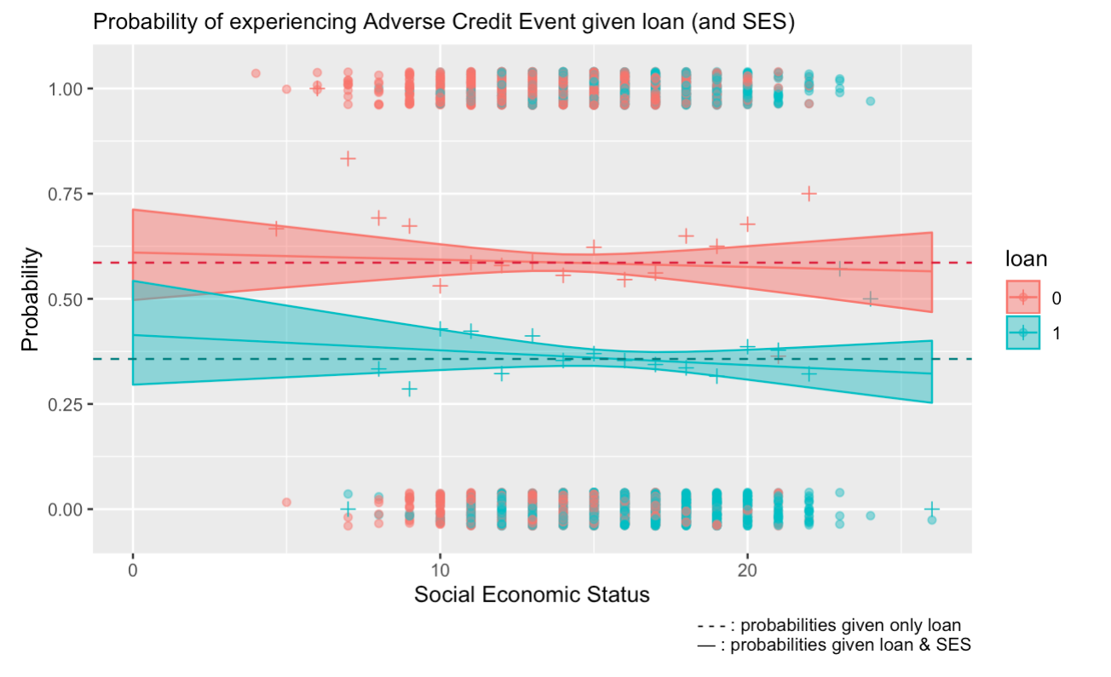 Figure 2. A comparison of probability estimate on adverse credit event given loan (and SES)

Figure 2 describes the difference in probability of experiencing adverse credit event (ACE) when receiving a loan and a comparison of how insignificant SES affect the probabilities as SES increases. The dashed line is the probability estimate for ACE given a loan or not (without SES), the dots describes the individuals who either experienced ACE or not, the +s are the proportion of ACE in each SES rank, while the line and ribbon are the fit of a logistic regression model and its 95% CI given SES.

The effects of loan on ACE is significant, $χ^{2}(4998)$ =6644.6, $p$ <.0001. In contrast, SES has almost no effect on ACE, $χ^{2}$ (4997)=6643.7, $p$ =.339 nor on the relationship loan has with ACE, $χ^{2}(4996)$ =6643.6, $p$ =.339.

The probability of those taking payday loan to experience ACE, .357 95% CI[.339 – .376], is lower than those who do not, .586 95% CI[.566 – .606], about an absolute .229 change in probability.

# In-depth Analysis

# --------- Exploratory Data Analysis  
  
summary(payday)

## credit.score SES loan well.being adverse.credit.event  
## Min. :400.0 Min. : 4 Min. :0.0000 Min. :1.000 Min. :0.0000   
## 1st Qu.:450.0 1st Qu.:13 1st Qu.:0.0000 1st Qu.:3.000 1st Qu.:0.0000   
## Median :500.0 Median :15 Median :1.0000 Median :4.000 Median :0.0000   
## Mean :499.3 Mean :15 Mean :0.5178 Mean :4.011 Mean :0.4674   
## 3rd Qu.:550.0 3rd Qu.:17 3rd Qu.:1.0000 3rd Qu.:5.000 3rd Qu.:1.0000   
## Max. :600.0 Max. :26 Max. :1.0000 Max. :7.000 Max. :1.0000

plot_histogram(payday)

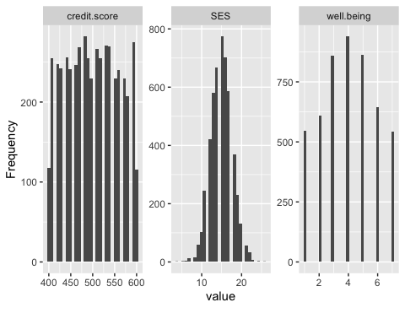

pairs(payday, panel=panel.smooth)

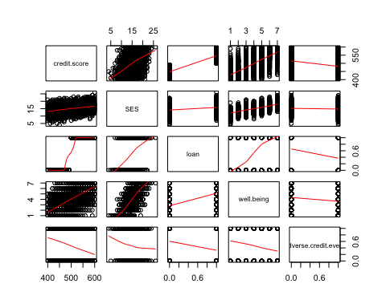

plot_correlation(payday)

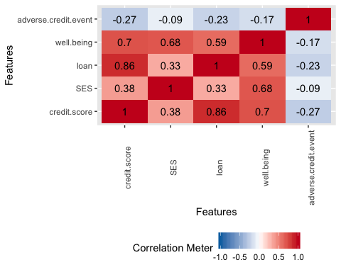

grid.arrange(  
 ggplot(payday, aes(y=well.being, x=credit.score,colour=as.factor(payday$loan))) + geom_point(mapping = aes(colour=as.factor(payday$loan))) + scale_y_continuous(breaks = 1:7) +labs(x="Credit score", y="Well-being",title="Relationship between credit.score and well.being by loan",col="Loan") + geom_smooth(method=lm),  
   
 ggplot(payday, aes(y=well.being, x=SES,colour=as.factor(payday$loan))) + geom_jitter() +scale_y_continuous(breaks = 1:7)+ labs(x="Social Economic Status", y="Well-being",title="Relationship between SES and well.being by loan",col="Loan") +geom_smooth(method=lm))

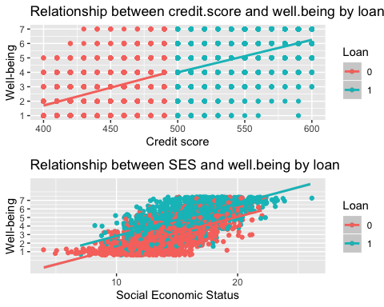

# --------- Compute R^2 among variables to understand the multicoliniarity.  
round((cor(payday))^2, digits = 3)

## credit.score SES loan well.being adverse.credit.event  
## credit.score 1.000 0.148 0.743 0.494 0.071  
## SES 0.148 1.000 0.108 0.467 0.008  
## loan 0.743 0.108 1.000 0.354 0.053  
## well.being 0.494 0.467 0.354 1.000 0.030  
## adverse.credit.event 0.071 0.008 0.053 0.030 1.000

loan and credit.score has relatively high correlation with each other ($R^{2}=.743$), . However, credit.score ($R^{2}=.494$) can explain well.being better than loan ($R^{2}=.354$). Therefore, it is within expectation that credit.score might be a more significant independant variable than loan in a multiple regression for well.being.

# --------- Linear regression on bivariate  
LM_loan <- lm(well.being~ loan, data=payday)  
LM_credit.score <- lm(well.being~ credit.score, data=payday)   
LM_ses <- lm(well.being~ SES, data=payday)   
  
# --------- Multiple regression models for well.being  
LM_credit.loan <- lm(well.being~ credit.score + loan, data=payday) # model1, without SES   
LM_credit.loan.ses <- lm(well.being ~ credit.score + loan + SES , data=payday) # model2, including SES

LM_credit.loan has loan and credit.score as independent variables for well.being. While, LM_credit.loan.ses in addition to what LM_credit.loan has, SES is added.

# --------- NHST whether the variables are significant in a bivariate setup  
anova(LM_loan)

## Analysis of Variance Table  
##   
## Response: well.being  
## Df Sum Sq Mean Sq F value Pr(>F)   
## loan 1 5852.6 5852.6 2738.6 < 2.2e-16 ***  
## Residuals 4998 10680.9 2.1   
## ---  
## Signif. codes: 0 '***' 0.001 '**' 0.01 '*' 0.05 '.' 0.1 ' ' 1

anova(LM_credit.score)

## Analysis of Variance Table  
##   
## Response: well.being  
## Df Sum Sq Mean Sq F value Pr(>F)   
## credit.score 1 8163.1 8163.1 4874.3 < 2.2e-16 ***  
## Residuals 4998 8370.3 1.7   
## ---  
## Signif. codes: 0 '***' 0.001 '**' 0.01 '*' 0.05 '.' 0.1 ' ' 1

anova(LM_ses)

## Analysis of Variance Table  
##   
## Response: well.being  
## Df Sum Sq Mean Sq F value Pr(>F)   
## SES 1 7722.4 7722.4 4380.5 < 2.2e-16 ***  
## Residuals 4998 8811.0 1.8   
## ---  
## Signif. codes: 0 '***' 0.001 '**' 0.01 '*' 0.05 '.' 0.1 ' ' 1

# --------- NHST whether the variance differ between multiple regression model with and without SES  
#H0: LM_credit.loan == LM_credit.loan.ses ; HA: LM_credit.loan != LM_credit.loan.ses   
anova(LM_credit.loan, LM_credit.loan.ses)

## Analysis of Variance Table  
##   
## Model 1: well.being ~ credit.score + loan  
## Model 2: well.being ~ credit.score + loan + SES  
## Res.Df RSS Df Sum of Sq F Pr(>F)   
## 1 4997 8362.8   
## 2 4996 5053.0 1 3309.8 3272.5 < 2.2e-16 ***  
## ---  
## Signif. codes: 0 '***' 0.001 '**' 0.01 '*' 0.05 '.' 0.1 ' ' 1

# --------- NHST the significance of the variables  
# For each variable... H0: model with variable == model without variable ; HA: model with variable != model without variable  
anova(LM_credit.loan.ses)

## Analysis of Variance Table  
##   
## Response: well.being  
## Df Sum Sq Mean Sq F value Pr(>F)   
## credit.score 1 8163.1 8163.1 8071.0331 < 2.2e-16 ***  
## loan 1 7.5 7.5 7.4561 0.006344 **   
## SES 1 3309.8 3309.8 3272.4871 < 2.2e-16 ***  
## Residuals 4996 5053.0 1.0   
## ---  
## Signif. codes: 0 '***' 0.001 '**' 0.01 '*' 0.05 '.' 0.1 ' ' 1

All bivariate LMs has significant effect on well.being, but when put together, the significance of loan shifts to credit.score. This comes back again to the fact that credit.score and loan are highly correlated. But credit.score still have the upperhand when it comes to predicting well.being.

The LM_credit.loan.ses fits significantly better, F=3272.5 and p < .0001, with an increase of 0.2 in $R^{2}$ and a decrease in 3309 of RSS compared to LM_credit.loan. We can say that adding SES explains an additional 20% of the variance in well being and it is statistically significant.

All independent variables in LM_credit.loan.ses are significant, but compared to credit.score and credit.score, loan is the least significant, p=.006.

# --------- the equation for wellbeing  
summary(LM_credit.loan.ses)

##   
## Call:  
## lm(formula = well.being ~ credit.score + loan + SES, data = payday)  
##   
## Residuals:  
## Min 1Q Median 3Q Max   
## -3.8283 -0.6951 0.0084 0.6656 3.7784   
##   
## Coefficients:  
## Estimate Std. Error t value Pr(>|t|)   
## (Intercept) -9.5881336 0.2233281 -42.933 <2e-16 ***  
## credit.score 0.0173921 0.0005017 34.667 <2e-16 ***  
## loan -0.1324966 0.0561764 -2.359 0.0184 *   
## SES 0.3322207 0.0058075 57.206 <2e-16 ***  
## ---  
## Signif. codes: 0 '***' 0.001 '**' 0.01 '*' 0.05 '.' 0.1 ' ' 1  
##   
## Residual standard error: 1.006 on 4996 degrees of freedom  
## Multiple R-squared: 0.6944, Adjusted R-squared: 0.6942   
## F-statistic: 3784 on 3 and 4996 DF, p-value: < 2.2e-16

cbind(coef(LM_credit.loan.ses), confint(LM_credit.loan.ses)) #Confidence interval of the estimate

## 2.5 % 97.5 %  
## (Intercept) -9.58813364 -10.02595471 -9.15031256  
## credit.score 0.01739205 0.01640852 0.01837558  
## loan -0.13249660 -0.24262709 -0.02236611  
## SES 0.33222068 0.32083547 0.34360589

well.being can be explained through the following equation: $\hat{well.being}=-9.588+0.017×credit.score-0.132×loan+0.332×SES$

As for the magnitude of change, holding credit.score and SES constant, one unit increase on loan variable predicts a decrease of .132 units on well.being 95% CI[(-.242) – (-.022)]. Such change is significant, $t(4996)=-2.359$, $p<.001$.

The negative coefficient of loan can be explained by the multiple colinearity with credit.score, the binary input, and the constraint of 7 scales of well.being. Simply put, loan balances credit.score’s impact by going to the opposite direction when loan == 1.

# --------- plot prep  
df_coeff <- as.data.frame(cbind(coef(LM_credit.loan.ses), confint(LM_credit.loan.ses)))  
df_coeff <- mutate(df_coeff, id = rownames(df_coeff))  
df_coeff <- anti_join(df_coeff, subset(df_coeff, id=='(Intercept)'))

## Joining, by = c("V1", "2.5 %", "97.5 %", "id")

df_coeff <- df_coeff %>%  
 mutate(V1 = round(V1,digits = 3))  
  
df_coeff$id[df_coeff$id == "credit.score"] <- "credit.score ***"  
df_coeff$id[df_coeff$id == "loan"] <- "loan **"  
df_coeff$id[df_coeff$id == "SES"] <- "SES ***"  
  
# --------- plotting  
ggplot(df_coeff , aes(y=as.factor(id), x=V1)) +   
 geom_point() + geom_text(aes(label=V1),hjust=0.5, vjust=2) +  
 labs(x="Regression Coefficient (slope)", y="Predictors",subtitle="How much an increase in one unit of credit.score, loan, or SES changes well.being", caption = "significance code: ** = p < 0.001, *** = p < 0.0001\n model intercept: -9.588 " ) +   
 geom_segment(aes(x=`2.5 %`,xend=`97.5 %`,y=as.factor(id),yend=as.factor(id) )) +   
 geom_vline(xintercept = 0, linetype='dotted')

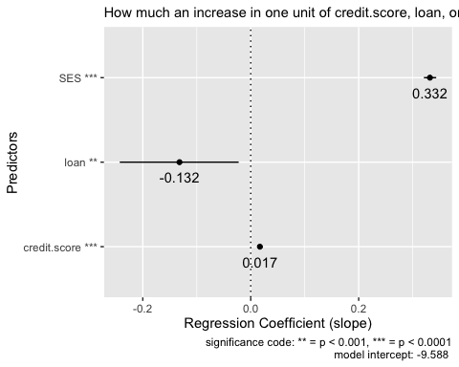

# --------- Exploratory Data Analysis  
mu <- payday %>%  
 group_by(adverse.credit.event) %>%  
 summarise(mean=mean(credit.score))  
  
ggplot(payday, aes(x=credit.score, color=as.factor(adverse.credit.event), fill=as.factor(adverse.credit.event))) +  
 geom_histogram(alpha =0.5, position="dodge", bins = 50)+  
 geom_density(alpha=0.6)+  
 geom_vline(data=mu, aes(xintercept=mean, color=as.factor(adverse.credit.event)),linetype="dashed")+  
 geom_vline(xintercept = 500, colour="#990000", linetype="longdash")+  
 scale_color_manual(values=c("#999999", "#E69F00", "#56B4E9"))+  
 scale_fill_manual(values=c("#999999", "#E69F00", "#56B4E9"))+  
 theme(legend.position="top")

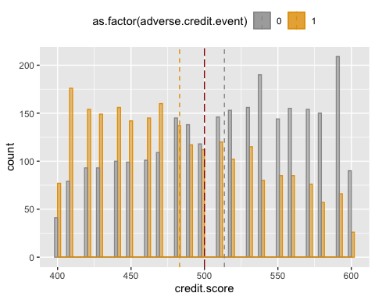

# --------- Build logistic regression model   
adverse.by.loan.ses <- glm(adverse.credit.event~loan*SES , family=binomial, data=payday)  
adverse.by.loan <- glm(adverse.credit.event~loan, family=binomial, data=payday)  
  
summary(adverse.by.loan.ses)

##   
## Call:  
## glm(formula = adverse.credit.event ~ loan * SES, family = binomial,   
## data = payday)  
##   
## Deviance Residuals:   
## Min 1Q Median 3Q Max   
## -1.3567 -0.9561 -0.9214 1.0392 1.4914   
##   
## Coefficients:  
## Estimate Std. Error z value Pr(>|z|)   
## (Intercept) 0.447556 0.234026 1.912 0.0558 .  
## loan -0.795326 0.353494 -2.250 0.0245 *  
## SES -0.007080 0.016331 -0.434 0.6646   
## loan:SES -0.008152 0.023251 -0.351 0.7259   
## ---  
## Signif. codes: 0 '***' 0.001 '**' 0.01 '*' 0.05 '.' 0.1 ' ' 1  
##   
## (Dispersion parameter for binomial family taken to be 1)  
##   
## Null deviance: 6910.2 on 4999 degrees of freedom  
## Residual deviance: 6643.6 on 4996 degrees of freedom  
## AIC: 6651.6  
##   
## Number of Fisher Scoring iterations: 4

summary(adverse.by.loan)

##   
## Call:  
## glm(formula = adverse.credit.event ~ loan, family = binomial,   
## data = payday)  
##   
## Deviance Residuals:   
## Min 1Q Median 3Q Max   
## -1.3282 -0.9396 -0.9396 1.0338 1.4355   
##   
## Coefficients:  
## Estimate Std. Error z value Pr(>|z|)   
## (Intercept) 0.34772 0.04135 8.409 <2e-16 ***  
## loan -0.93659 0.05825 -16.080 <2e-16 ***  
## ---  
## Signif. codes: 0 '***' 0.001 '**' 0.01 '*' 0.05 '.' 0.1 ' ' 1  
##   
## (Dispersion parameter for binomial family taken to be 1)  
##   
## Null deviance: 6910.2 on 4999 degrees of freedom  
## Residual deviance: 6644.6 on 4998 degrees of freedom  
## AIC: 6648.6  
##   
## Number of Fisher Scoring iterations: 4

# --------- Get the probability of adverse credit event by loan and its estimation  
adverse.by.loan.emm <- emmeans(adverse.by.loan, ~loan, type="response")  
confint(adverse.by.loan.emm)

## loan prob SE df asymp.LCL asymp.UCL  
## 0 0.586 0.01003 Inf 0.566 0.606  
## 1 0.357 0.00942 Inf 0.339 0.376  
##   
## Confidence level used: 0.95   
## Intervals are back-transformed from the logit scale

# --------- Plot the probabilities  
ggplot(summary(adverse.by.loan.emm), aes(x=as.factor(loan), y=prob, ymin=asymp.LCL, ymax=asymp.UCL)) + geom_point() + geom_linerange() + labs(x="Loan", y="Proportion of adverse credit event") +  
 geom_hline(yintercept = 0.586, lty=2) +  
 geom_hline(yintercept = 0.357, lty=2)

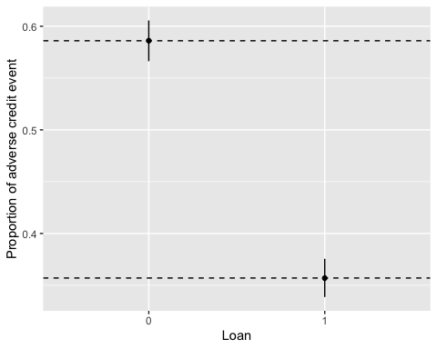

# --------- Prove that SES is insignificant for explaining adverse.credit.event  
anova(adverse.by.loan.ses, test="Chisq")

## Analysis of Deviance Table  
##   
## Model: binomial, link: logit  
##   
## Response: adverse.credit.event  
##   
## Terms added sequentially (first to last)  
##   
##   
## Df Deviance Resid. Df Resid. Dev Pr(>Chi)   
## NULL 4999 6910.2   
## loan 1 265.597 4998 6644.6 <2e-16 ***  
## SES 1 0.913 4997 6643.7 0.3394   
## loan:SES 1 0.123 4996 6643.6 0.7259   
## ---  
## Signif. codes: 0 '***' 0.001 '**' 0.01 '*' 0.05 '.' 0.1 ' ' 1

A change of probability of ACE between receiving a loan and not receiving one is about an absolute 22.9%. Additionally, SES has almost no effect on ACE, $χ^{2}$ (4997)=6643.7, $p$ =.339 nor on the relationship loan has with ACE, $χ^{2}(4996)$ =6643.6, $p$ =.339.

# --------- Plot Prep  
adverse.by.loan.ses.emm <- emmeans(adverse.by.loan.ses, ~loan*SES, at=list(SES=seq(0,26,1)), type="response")  
ses.unique<- unique(payday$SES)  
payday_t <- payday %>%   
 mutate(SES.deciles=cut(SES, breaks=ses.unique, include.lowest=TRUE))  
  
payday_t.loan.ses <- payday_t %>%   
 group_by(SES.deciles,loan) %>%   
 summarise(Proportion.adverse=mean(adverse.credit.event), decile.mean.ses=mean(SES))  
  
payday_t$loan <- as.factor(payday_t$loan)  
payday_t.loan.ses$loan <- as.factor(payday_t.loan.ses$loan)  
  
  
sum_adverse.by.loan.ses.emm <- as.data.frame(summary(adverse.by.loan.ses.emm))  
sum_adverse.by.loan.ses.emm$loan <- as.factor(sum_adverse.by.loan.ses.emm$loan)  
  
# --------- Plotting mainplot  
ggplot(sum_adverse.by.loan.ses.emm, aes(x=SES, col=loan, fill=loan,y=prob, ymin=asymp.LCL, ymax=asymp.UCL)) +   
 geom_jitter(data=payday_t, mapping=aes(y=adverse.credit.event, x=SES, col=loan,ymin=NULL, ymax=NULL), height=0.04, width=0, alpha=0.5) +   
 geom_point(data=payday_t.loan.ses, mapping=aes(y=Proportion.adverse, x=decile.mean.ses, col=loan, ymin=NULL, ymax=NULL), size=2, shape=3) +  
 geom_ribbon(alpha = 0.5) +   
 geom_line() +  
 labs(x="Social Economic Status", y="Probability", caption="- - - : probabilities given only loan \n — : probabilities given loan & SES", subtitle = "Probability of experiencing Adverse Credit Event given loan (and SES)" ) +   
 ylim(-0.05,1.05) +  
 geom_hline(yintercept = 0.586, lty=2, color='#DC143C') +  
 geom_hline(yintercept = 0.357, lty=2, color='#008080')

